1. Using vi write your CV in the file mycv. Your CV should include your name, age, school, college, experience,... 🡪 vi mycv

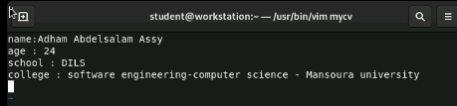

2. Open mycv file using vi command then: Without using arrows state how to:

a. Move the cursor down one line at time. 🡪 press j

b. Move the cursor up one line at time. 🡪 press k

c. Search for word age 🡪 :/age

d. Step to line 5 (assuming that you are in line 1 and file is more than 5 lines). 🡪 5G

e. Delete the line you are on and line 5. 🡪dd , :5d

f. How to step to the end of line and change to writing mode in one-step. 🡪 press A

3. List the available shells in your system. 🡪 cat /etc/shells

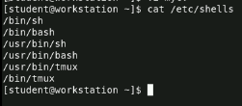

4. List the environment variables in your current shell. 🡪printenv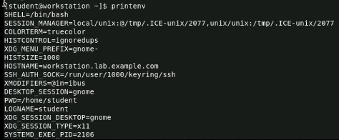

5. List all of the environment variables for the bash shell. 🡪printenv

6. What are the commands that list the value of a specific variable? 🡪 echo $VARIABLENAME

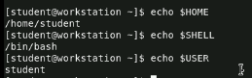

7. Display your current shell name. 🡪 echo $SHELL

8. State the initialization files of: sh, ksh, bash.

🡪sh : /etc/profile , ~/.profile

🡪ksh : /etc/profile , ~/.profile , ~/.kshrc

🡪bash: /etc/profile , ~/.profile , ~/.bashrc

9. Edit in your profile to display date at login and change your prompt permanently. 🡪 gedit ~/.bashrc 🡪echo $(date) 🡪 save & exit 🡪close terminal and open again

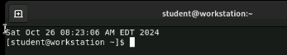

10. Execute the following command:

echo \ then press enter

What is the purpose of \ ? 🡪 line continuation , splitting into multiple lines

Notice the prompt ">" what is that? and how can you change it from ">" to ":".

(>) 🡪 The command isn’t complete

🡪echo $PS1 🡪echo $PS2 🡪 PS2=”:” 🡪 echo \

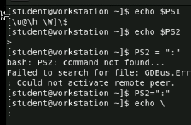

11. Create a Bash shell alias named Is for the "Is -I" command

🡪gedit ~/.bashrc 🡪alias ls=’ls -l’ 🡪 save & exit 🡪 close terminal and open it again 🡪 ls

